MEDIA KIT

It is often said that the world is urbanizing, but that is not exactly right. To be more precise, the world is suburbanizing.

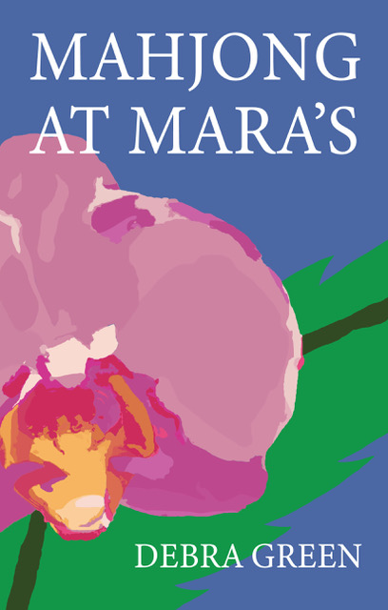

Suburban New Jersey—the quintessential quagmire of coexistence. Neighboring communities comprised of people of multiple ethnicities and financial status—converging at the local gas station, supermarket, and café— speaking in snippets of feigned and genuine cordiality. People with whom we rarely envision sharing anything more of ourselves … until we do.
SYNOPSIS
Seventeen years after losing the love of her life on 9/11, Lila, a nurse aide, and her teenage son Dante find solace in unlikely companions— a group of Mahjong-playing octogenarians. There's Lila's client Thea struggling with Alzheimer's, and her sweet husband, Joseph; Mali, a lonely Holocaust survivor living far away from her only daughter; childless and recently widowed Frank; and the persnickety, divorced Gladys, whom Mali disliked from the moment the two met. When Brian, a duplicitous new neighbor, and Dante’s friends Rashon and Giselle join the mix, all their lives take surprising turns that raise questions about the concepts of family, loyalty, and love.
A bighearted novel with an endearing and diverse cast of characters,
MAHJONG AT MARA’S illustrates the bumpy ride to understanding experienced by the complicated patchwork of people who make up suburban America.

TRIM SIZE: 5.5 x 8.5

PRICE: Print $19.95 E-Book $9.95

ISBNs: Print ISBN 979-8-9895449-0-5 E-Book 979-9-9895449-1-2

PUBLICATION DATE: 02.06.2024

PUBLISHER:

PAGES: 346

ADDITIONAL ITEMS IN THE BOOK:
Reading Group Guide

AVAILABLE ON AMAZON

KEY SELLING POINTS

TIMELY THEMES As suburban America becomes more and more integrated, there is increasing interest in the challenges of race relations. The novel raises this issue and provides a Reading Group Guide to promote discussion.

CROSSES TWO GENRES The novel fits into both the contemporary and YA genres.

AUDIENCE
- Female fans of contemporary fiction
- Fans of Jewish fiction
- Fans of Black fiction

BLURBS
“A touching, multifaceted story about unexpected connections fostered by a shared love of an ancient game. Each member of this found family weaves a colorful thread into the greater tapestry of the novel." —Heather Frimmer, author of Bedside Manners and Better to Trust
“In Mahjong at Mara’s, Debra Green paints a complex cast of characters—from teens to seniors, widowers to single moms—who persevere through a year filled with life, death, college applications, grow houses, new romances, orchids, and even a dognapping. Fans of Clare Pooley and Elyssa Friedland will love this portrait of the hope that comes from human connection."—Andrea J. Stein, author of Typecast
“Debra Green’s Mahjong at Mara’s is a beautiful portrait of mainstream America spanning age groups from teenagers to the elderly. Protagonist Lila’s life is central—though several secondary characters are so well drawn that they could also claim leading roles. This novel is a delight to read.”—Adele Holmes, MD, author of Winter’s Reckoning

“For those of us missing community in these uncertain times, when we’ve had way too much of
our own company, Debra Green’s hopeful novel serves as a reminder that when we take a risk and reach out to each other, we may find we have more in common than we ever thought possible. Mahjong at Mara’s is a sometimes lighthearted, sometimes serious, but always heartwarming reminder that maybe, just maybe, all you need is love, understanding-- and a little friendly rivalry.”—Deborah K. Shepherd, author of So Happy Together

“Mahjong at Mara’s, Debra Green’s generous, warmhearted new novel, weaves a compassionate tale of intergenerational connection and support. In the wilds of New Jersey, a hodgepodge of souls, including a group of Jewish and Italian retirees, a Black healthcare worker, her sixteen-year-old son, his friends, and a reluctant mob operative come together over mahjong, to the benefit and betterment of all. Green deftly handles her large cast of characters, building individual story arcs to a thrilling and suspenseful climax. Exciting and wise, Mahjong at Mara’s shows us that, regardless of age, everyone has something to teach and something to learn. It’s a worthy life lesson. This book will linger long after you’ve turned the last page.”
—Gail Lehrman, author of Across Seward Park

“No matter who we are or where we come from, life can be a difficult and often lonely journey. Debra Green’s Mahjong at Mara’s is the heartwarming story of how an unlikely group of people come together and forge ties that might overcome entrenched biases and a near tragedy.”
—Heidi Hackford, author of Folly Park

“Mahjong at Mara's showcases Debra Green's stunning talent for intertwining the stories of individuals whose starkly different lives share the impacts of their unique dreams and vulnerabilities. It also reveals the delicate beauty and fragility that underlies complex and often unexpected relationships.”—Robin Rosen Chang, author of The Curator’s Notes

Debra Green’s Mahjong at Mara’s skillfully takes an ensemble set of diverse characters and briskly intermingles their lives the way mahjong tiles come together and separate to bring the players victory—or defeat. Young and Black or Old and white or Other, the characters draw the reader along on a journey well worth traveling together.—Esther Erman, author of Rebecca of Salerno

AUTHOR BIO
Lonnie Juli Photography high-resolution

Debra Green, author of MAHJONG AT MARA’S and THE CONVENTION OF WIVES, has an interest in interpersonal dynamics, history, and tradition that informs the stories she weaves. A former hospital administrator and grant writer, she lives with her husband, David, in Scotch Plains, New Jersey where they raised their three children.

Publishing History
MAHJONG AT MARA’S will be published in February 2024 by Denouement Press.
THE CONVENTION OF WIVES, Debra’s debut novel, was published in September 2022 by She Writes Press. Debra was a 2022 Jewish Book Council (JBC) author whose 35 plus presentations at JCCs, synagogues, corporate events, and private book clubs included: Boca Raton JCC’s Authors Day (4 featured authors/attendance 400); The Park Avenue Club’s Book Club; West Elm’s Holiday Program; and Shackamaxon Country Club’s Play for Pink. Additional programs are scheduled. She will be participating as a 2024 JBC author.

Debra appeared on Launch Pad Radio and Julia Daily on Authors Over 50; has been interviewed in the Columbia University Fiction Foundry Newsletter and JScreen’s and The National Gaucher Foundation’s blogs; and conceptualized and participated in an author-to-author program with Kristen Harnisch sponsored by the Napa Historical Society.

Education
BA, Biology and Psychology, Rutgers University
MPH, Columbia University
Student, The Writers Circle, Summit, NJ

Memberships
The Authors Guild Women Fiction Writers Association
Columbia University Fiction Foundry Shut Up and Write Westfield

